|  |
| --- |
| Group 1 |
| Controlled Environment Monitors |
| Service Manual ( June 19 ) |

Contents

Basics 3

Product View 3

Overview 3

Display Unit 4

Tools 4

Warning 4

Disassembly and Repair 5

Replacing the Battery 5

Part Location 5

Procedure 5

Opening the Display Unit 5

Closing the Display Unit 6

Replacing the LCD 6

Part Location 6

Procedure 6

Replacing the Keypad 6

Part Location 6

Procedure 6

Replacing the Buzzer 7

Part Location 7

Procedure 7

Replacing the SD Card Reader 7

Part Location 7

Procedure 7

Replacing the Switch / LEDs 8

Part Location 8

Procedure 8

Replacing Printed Circuit Board 8

Part Location Procedure 8

Exploded View 9

Display Unit PCB Layout and Schematics 10

Sensor Unit 11

Parts and Procedures 11

Tools 11

Warning 11

Disassembly and Repair 12

Replacing the Battery 12

Part Location 12

Procedure 12

Accessing Internal Components 12

Replacing the Humidity Sensor / Light Sensor 13

Part Location 13

Procedure 13

Replacing the Switch / LED 13

Part Location 13

Procedure 13

Replacing Printed Circuit Board 14

Part Location 14

Procedure 14

Exploded Views 15

Sensor Unit PCB Layout and Schematics 16

# Basics

## Product View

Sensor Unit

Display Unit

## Overview

Controlled Environment Monitors are designed to raise an alarm when surrounding parameters exceed pre-set thresholds. Unlike household sensors CEM is designed to work off the grid. This makes it suitable to be used for monitoring closed agricultural environments like propagators and green houses.

# Display Unit

# Tools

* Clean non-marring work surface
* #2 Phillips screwdriver (magnetized)
* Needle nose pliers
* Soft cloth (to protect removed parts from scratches)
* Screw tray
* Razor knife
* Glue Gun
* Rubbing Alcohol and Cotton Swabs (for removing Hot glue)

# Warning

In this manual, graphics or photos are intended to help illustrate procedures or information only, and may show different levels of disassembly, board colours, configurations than your device.

# Disassembly and Repair

## Replacing the Battery

### Part Location

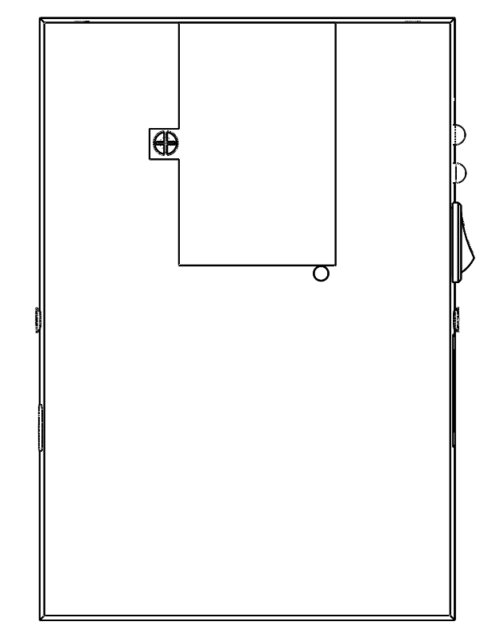

### Procedure

1. Turn off the Display unit
2. Place the Display unit with the LCD screen face down.
3. Rotate the battery cover

 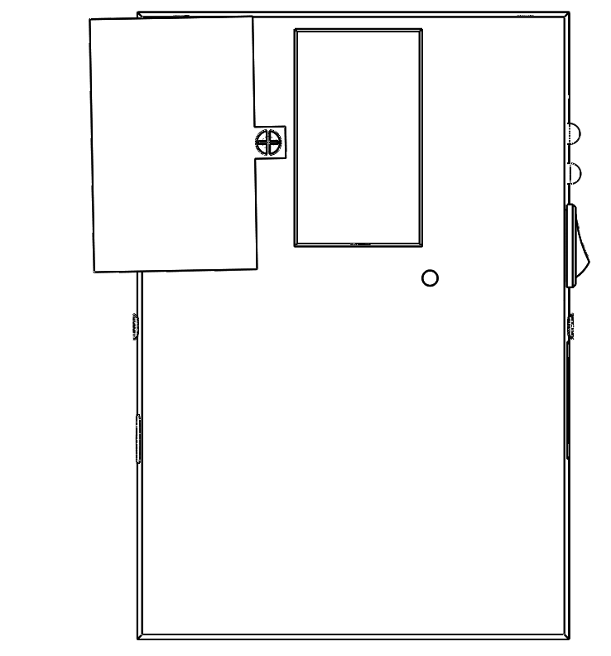

1. Disconnect the battery connector and remove the battery
2. Insert new battery (9V Alkaline recommended)

## Opening the Display Unit

1. Remove the Battery (see Replacing Battery)
2. Remove the screw on each side
3. Pry open* the top case by holding from the edges

*Warning: DO NOT pull apart the top cover without removing the connectors

1. Disconnect the Keypad connector and LCD connector from the PCB

## Closing the Display Unit

1. Connect the Keypad Connector and LCD connector
2. Align the Top cover and press down until it snaps
3. Insert the screws on each side.

## Replacing the LCD

### Part Location

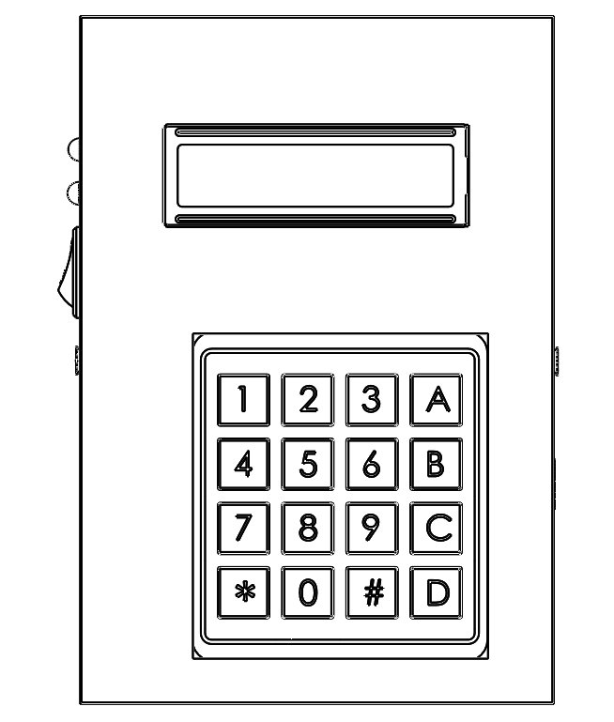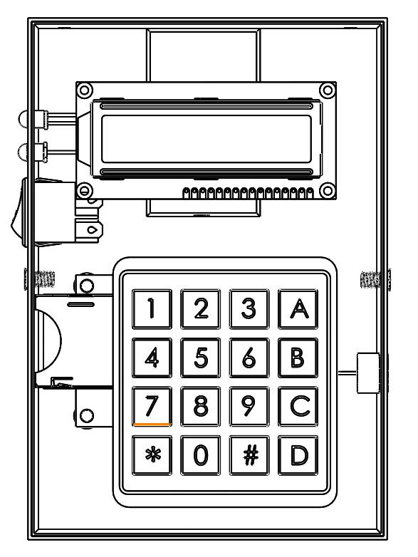

### Procedure

1. Open up the Display unit (See Opening the Display Unit)
2. Press firmly on the LCD and pop it out
3. Pop in the new display
4. Close the Display Unit (See Closing the Display Unit)

## Replacing the Keypad

### Part Location



### Procedure

1. Open up the Display unit (See Opening the Display Unit)
2. Use the Razor Knife to peel off the Keypad
3. Pull out the keypad and Ribbon
4. Insert the new keypad ribbon through the slot in the top cover
5. Apply Glue to the bottom of the keypad and paste it
6. Close the Display Unit (See Closing the Display Unit)

## Replacing the Buzzer

### Part Location

 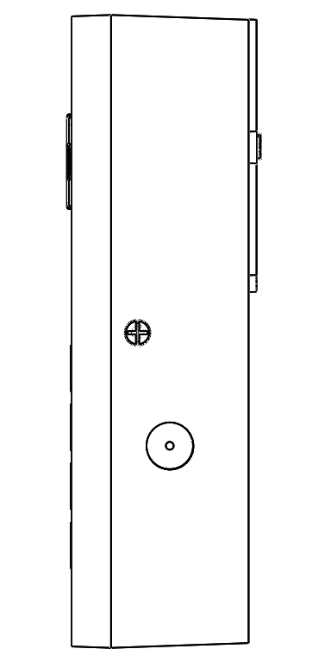 

### Procedure

1. Open up the Display unit (See Opening the Display Unit)
2. Disconnect the Buzzer connector
3. Press firmly on the Buzzer and pop it out
4. Pop in the new Buzzer
5. Reconnect the Buzzer connector
6. Close the Display Unit (See Closing the Display Unit)

## Replacing the SD Card Reader

### Part Location

 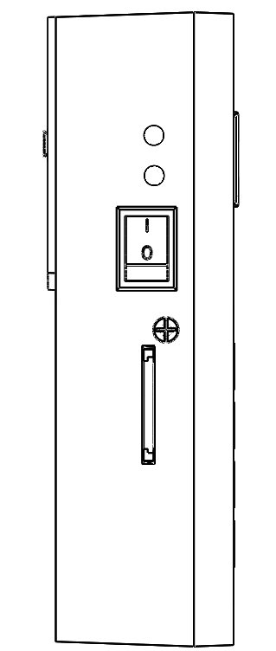 

### Procedure

1. Open up the Display unit (See Opening the Display Unit)
2. Disconnect the SD Card Reader connector
3. Use Rubbing Alcohol to remove the glue holding the SD Card Reader in place
4. Slide out the SD card reader
5. Slide in the New SD Card Reader
6. Use a Glue Gun to fix the new SD Card Reader in place
7. Reconnect the SD Card Reader connector
8. Close the Display Unit (See Closing the Display Unit)

## Replacing the Switch / LEDs

### Part Location

  

### Procedure

1. Open up the Display unit (See Opening the Display Unit)
2. Disconnect the Switch / LED connector
3. Press firmly on the Switch / LED and pop it out
4. Pop in the new Switch / LED
5. Reconnect the Switch / LED connector
6. Close the Display Unit (See Closing the Display Unit)

## Replacing Printed Circuit Board

### Part Location Procedure

1. Open up the Display unit (See Opening the Display Unit)
2. Disconnect the all connectors (SD Card Reader, LEDs, Buzzer, Switch )
3. Remove the 4 screws in the corners of the PCB
4. Pull out the PCB taking note of the orientation
5. Place new PCB in the correct orientation
6. Insert the screws and fix the PCB.
7. Reconnect all the connectors
8. Close the Display Unit (See Closing the Display Unit)

# Exploded View

# Display Unit PCB Layout and Schematics

# Sensor Unit

# Parts and Procedures

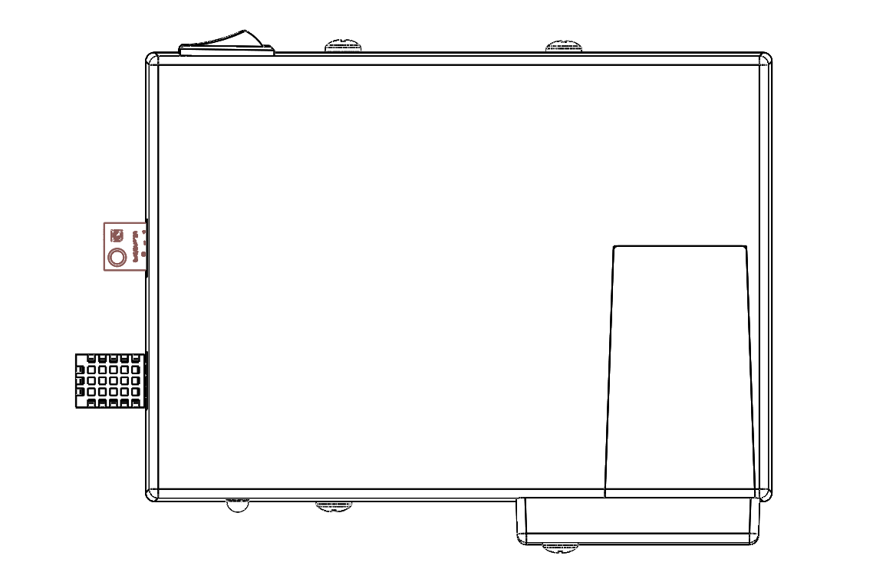

# Tools

* Clean non-marring work surface
* #2 Phillips screwdriver (magnetized)
* Needle nose pliers
* Soft cloth (to protect removed parts from scratches)
* Screw tray
* Putty knife (922-6761),1.5 inch (38 mm), flexible blade

# Warning

In this manual, graphics or photos are intended to help illustrate procedures or information only, and may show different levels of disassembly, board colors, configurations than your device.

# Disassembly and Repair

## Replacing the Battery

### Part Location

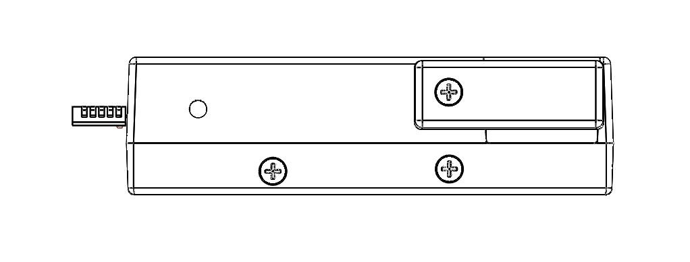

### Procedure

1. Turn off the Sensor unit
2. Place the Sensor unit on a side
3. Rotate the battery cover lock

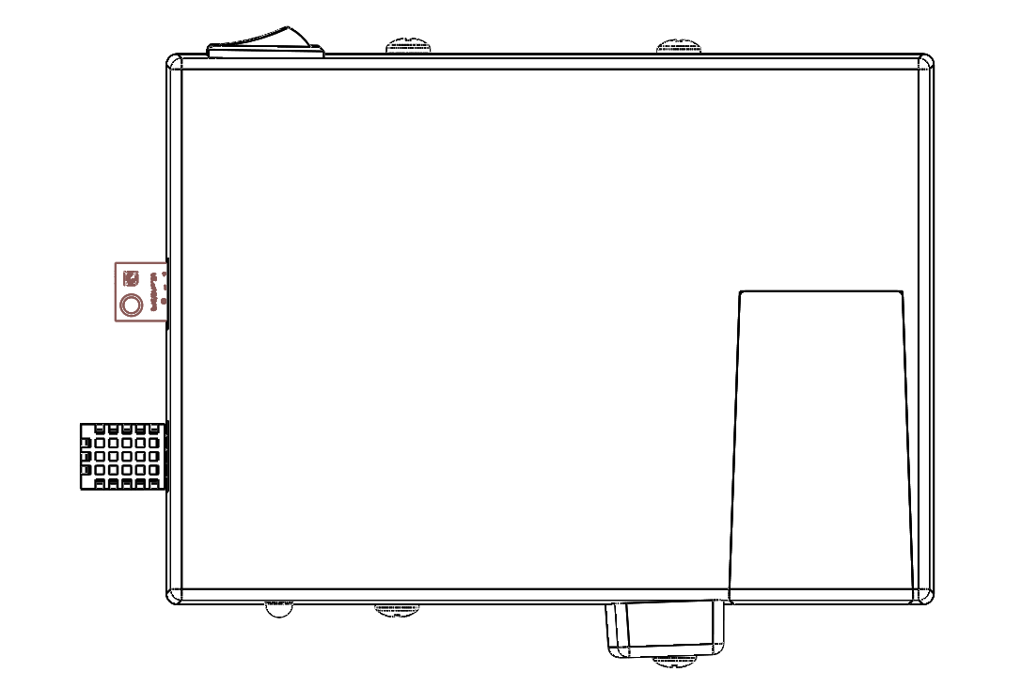 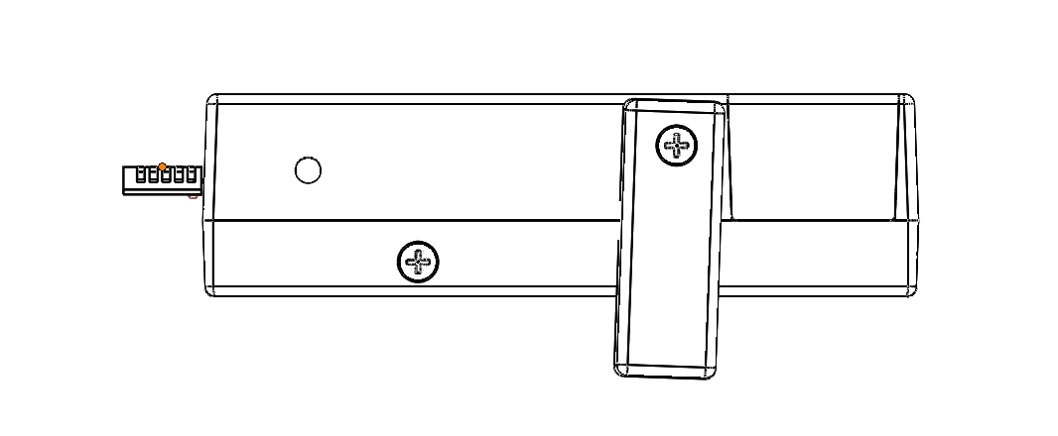

1. Slide the battery cover

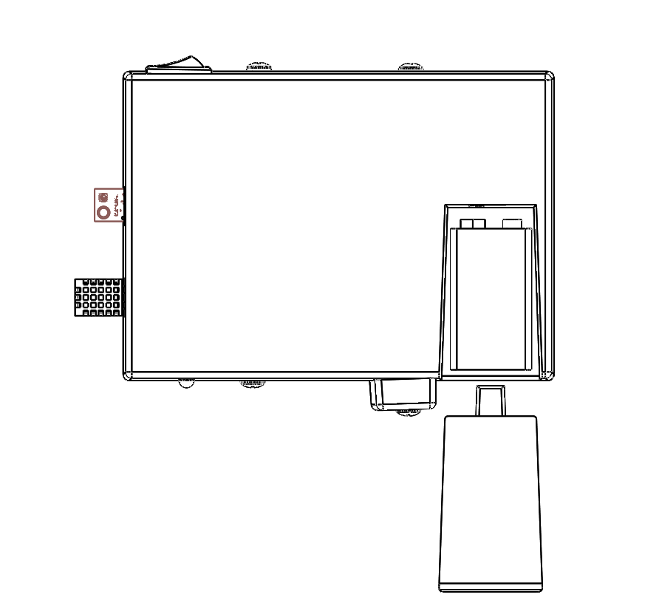

1. Disconnect the battery connector and take out the battery
2. Insert new battery
3. Slide in the battery cover and lock it in place by rotating the battery cover lock

## Accessing Internal Components

1. Remove the battery (See Replacing Battery)
2. Remove the 2 screws from each side
3. Pry open the top case by holding from the edges

## Replacing the Humidity Sensor / Light Sensor

### Part Location



Temperature and

Humidity Sensor

Light Sensor

### Procedure

1. Open up the Sensor unit (See Accessing Internal Components)
2. Disconnect the Humidity Sensor/ Light Sensor connector
3. Pull out the Humidity Sensor / Light Sensor
4. Insert the new Humidity Sensor / Light Sensor
5. Reconnect the sensor connector
6. Close the Sensor Unit (See Closing the Sensor Unit)

## Replacing the Switch / LED

### Part Location

Switch

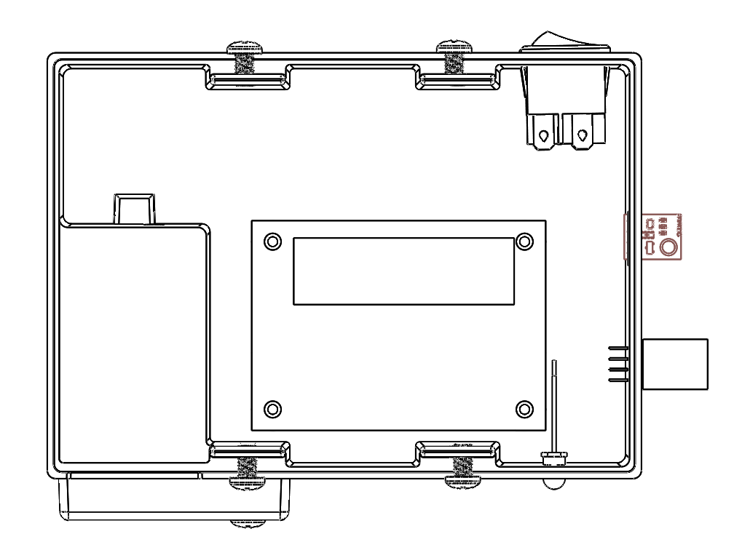

LED Battery Indicator

### Procedure

1. Open up the Sensor unit (See Accessing Internal Components)
2. Disconnect the Switch / LED connector
3. Press firmly on the Switch / LED and pop it out
4. Pop in the new Switch / LED
5. Reconnect the Switch / LED connector
6. Close the Sensor Unit (See Closing the Sensor Unit)

## Replacing Printed Circuit Board

### Part Location



### Procedure

1. Open up the Sensor unit (See Accessing Internal Components)
2. Disconnect the all connectors (Humidity Sensor, Light Sensor, LEDs, Switch)
3. Remove the 4 screws in the corners of the PCB
4. Pull out the PCB taking note of the orientation
5. Place new PCB in the correct orientation
6. Insert the screws and fix the PCB.
7. Reconnect all the connectors
8. Close the Sensor Unit (See Closing the Sensor Unit)

# Exploded Views

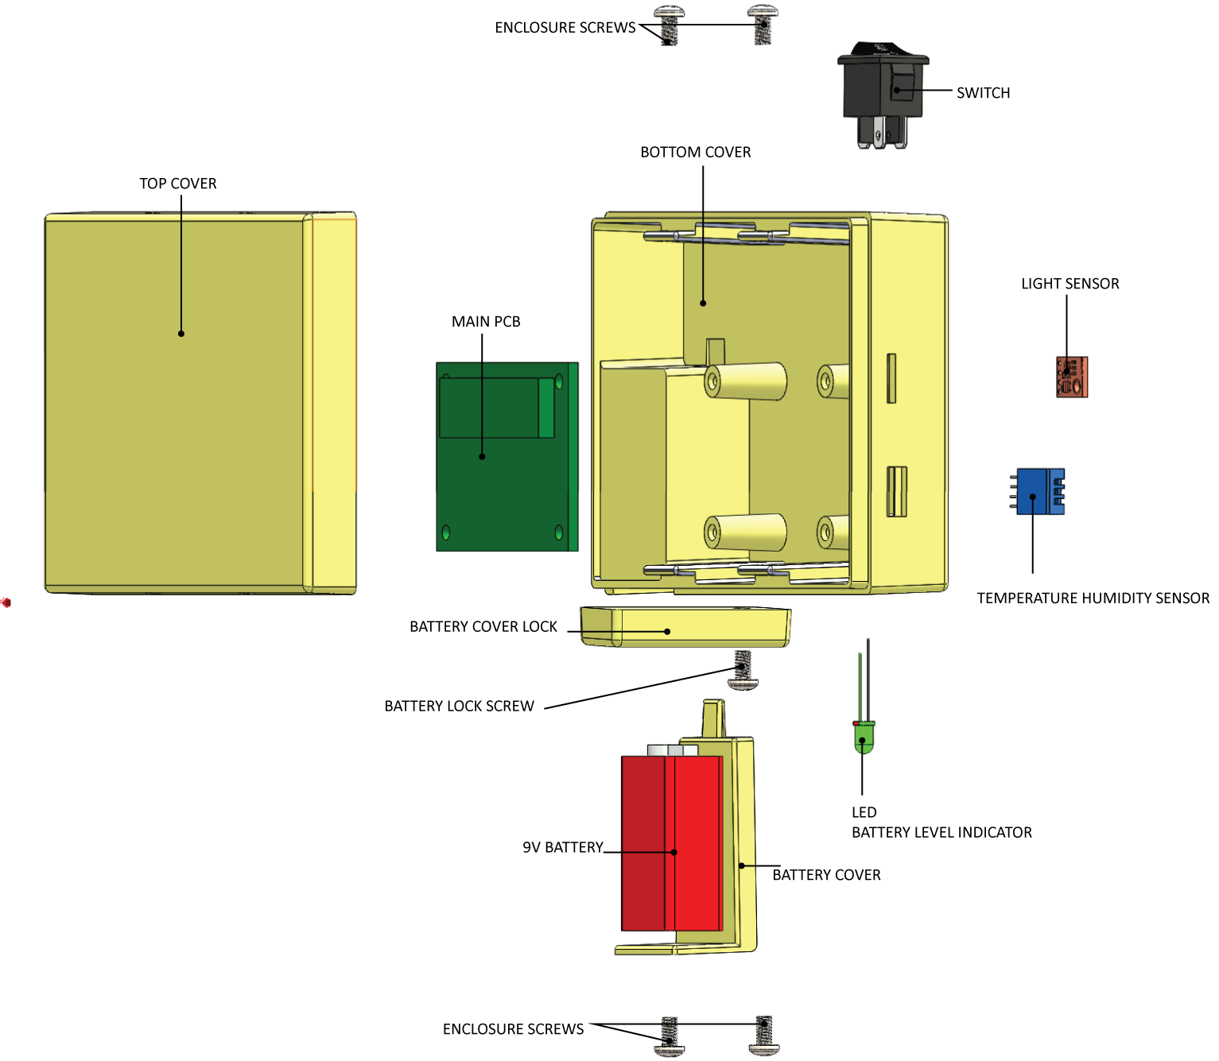

# Sensor Unit PCB Layout and Schematics